**7.0 Create Queries**

**Format list**

set linesize 300;

set pagesize 50;

column payment_no heading "Payment No.";

column amount heading "Amount";

column account_no heading "Account No.";

column amount format $9,990.90;

column payment_no format A15;

column account_no format A11;

set underline =;

column first_name heading "First Name";

column last_name heading "Last Name";

column first_name format A12;

column last_name format A12;

column fine_due heading 'Fine|Due Amount';

column fine_due format $9,990.90;

column date_joined heading 'Date|Joined';

column book_id heading "Book ID";

column book_title heading "Book Title";

column book_title format A30;

column language heading "Language";

column author heading "Author";

column language format A10;

column author format A20;

column publisher format A20;

column publish_year heading 'Publish|Year';

column date_created heading "Date Created";

column date_created format A12;

column reserve_no heading "Reserve No.";

column reserve_no format A11;

column reserve_date heading "Reserve Date";

column reserve_date format A12;

column collection_date heading 'Collection|Date';

column collection_date format A10;

column return_date heading 'Return|Date';

column return_date format A9;

column fine_no heading "Fine No.";

column fine_no format A8;

column day_count heading "Day Count";

column fine_amount heading "Fine Amount";

column fine_amount format $9,990.90;

column payment_date heading "Payment Date";

column payment_method format A12;

column payment_status heading "Payment Status";

column payment_status format A14;

column report_no heading "Report No.";

column report_no format A10;

column payment_method heading "Payment Method";

column payment_date format A12;

**7.1 Tan Qun Yih**

**7.1.1 Every fine for each book is for which account**

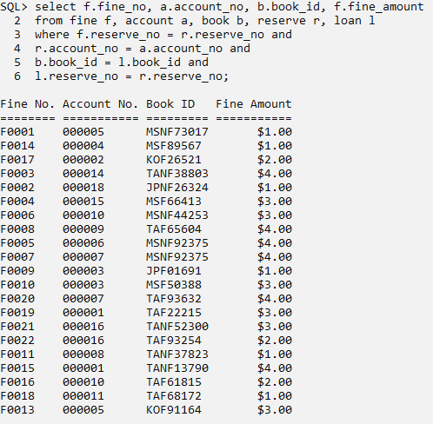

Use to identify the payment form the customer is for which fine.

**7.1.2 Number of books for each language that existed**

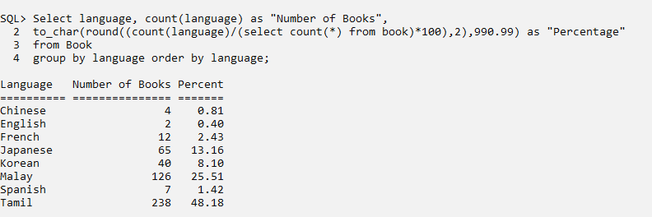

To make ease the task for the librarian to manage the total amount of books with desired languages.